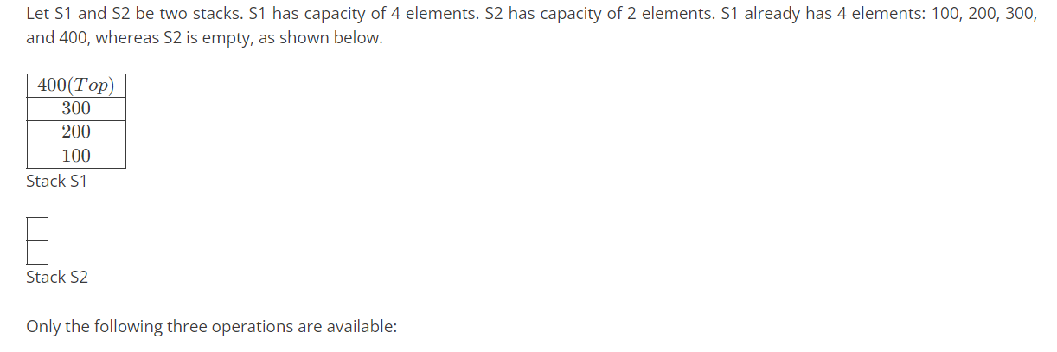

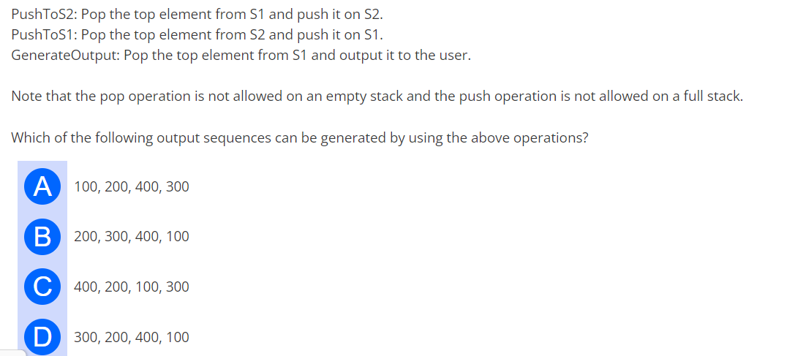

| 2.You are given a set V of distinct integers. A binary search tree T is created by inserting all elements of V one by one, starting with an empty tree. The tree T follows the convention that, at each node, all values stored in the left sub tree of the node are smaller than the value stored at the node. You are not aware of the sequence in which these values were inserted into T, and you do not have access to T. Which one of the following statements is TRUE? **[CS2024-2]** | |
| --- | --- |
| Inorder traversal of T can be determined from V |  |
| Root node of T can be determined from V |  |
| Preorder traversal of T can be determined from V |  |
| Postorder traversal of T can be determined from V |  |

| 3.Let A be an array containing integer values. The distance of A is defined as the minimum number of elements in A that must be replaced with another integer so that the resulting array is sorted in non-decreasing order. The distance of the array [2, 5, 3, 1, 4, 2, 6] is _______  **[CS2024-2]** | | | |
| --- | --- | --- | --- |
| B. 2 | C. 3 | D. 4 |  |

| 5 | 4.An array [82, 101, 90, 11, 111, 75, 33, 131, 44, 93] is heapified. Which one of the following options represents the first three elements in the heapified array? **[CS2024-1]** | | | |
| --- | --- | --- | --- | --- |
|  | A. 82,90,101 | B. 82,11,93 | C. 131,11,93 | D. 131,111,90 |

6.Consider the operator precedence and associativity rules for the integer arithmetic operators given in the table below.

| Operator | Precedence | Associativity |
| --- | --- | --- |
| + | Highest | Left |
| − | High | Right |
| ∗ | Medium | Right |
| / | Low | Right |

The value of the expression 3 + 1 + 5 ∗ 2/7 + 2 − 4 − 7 − 6/2 as per the above rules is ____

| **A. 2** | **B. 4** | **C. 6** | **D. 8** |
| --- | --- | --- | --- |

| **5.In a B+ tree, the requirement of at least half-full (50%) node occupancy is relaxed for which one of the following cases? [CS2024-1]** | |
| --- | --- |
| **Only the root node** |  |
| **All leaf nodes** |  |
| **All internal nodes** |  |
| **Only the leftmost leaf node** |  |

| 6.An array [82, 101, 90, 11, 111, 75, 33, 131, 44, 93] is heapified. Which one of the following options represents the first three elements in the heapified array? **[CS2024-1]** |
| --- |

| A. 82,90,101 | B. 82,11,93 | C. 131,11,93 | D. 131,111,90 |
| --- | --- | --- | --- |

| 7.Consider a binary min-heap containing 105 distinct elements. Let k be the index (in the underlying array) of the maximum element stored in the heap. The number of possible values of k is **[CS2024-1]** |
| --- |

| A. 53 | B. 52 | C. 27 | D. 1 |
| --- | --- | --- | --- |